**“How is your job affecting your mental health?”**

People’s health can be determined by many things; genetics, context, background, sickness, or even a crisis situation in your life. But did you know that your choosing of profession can affect your mental health?

According to different sources, these are the **top 10 most stressful jobs of 2018**, the list is based in the United States, but it estimates the stress of a career, regardless of where it is exercised.

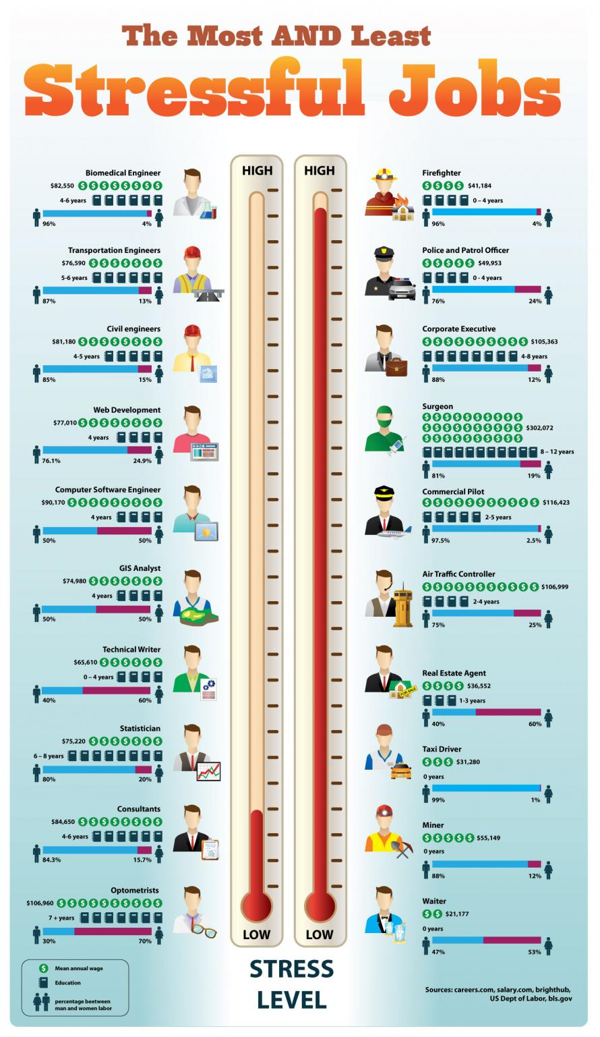 **Top 10 stressful jobs**

1. Firefighter
2. Police Officer
3. Corporation Executive
4. Surgeon
5. Commercial Pilot
6. Air traffic controller
7. Real estate agent
8. Taxi Driver
9. Minor
10. Waiter

**This is the list of the least stressful jobs**

1. Biomedical Engineer
2. Transportation Engineer
3. Civil engineers
4. Web development
5. Computer software engineer
6. GIS Analyst
7. Technical Writer
8. Statistician
9. Consultants
10. Optometrists

Odds are, if you were looking for your profession on the list of “**most stressful jobs**”, you probably do not have a stress free job. *Who does?* *Besides civil engineers of course.*

According to **World’s Health Organization** there are different factors that contribute to higher stress in your job, even if you’re not a firefighter or a surgeon.

These are some of the risks to mental health in your job:

* Inadequate safety and health protection policies.
* Inefficient management and communication practices.
* Lack of power of the worker to make decisions or lack of control of his work area.
* Low level of support for employees.
* Rigid work schedules
* Lack of clarity in the areas or organizational objectives.

*The risks can also be related to the content of the work. For example, the tasks assigned to a person may not suit their competencies and or the workload may be permanently high.* (Organización Mundial de la Salud, 2017)

Some jobs, such as those performed by humanitarian and first-intervention personnel, carry a higher mental health risk, it can affect and cause symptoms such of those of psychiatric disorders, and it can also trigger a harmful consumption of alcohol, drugs or psychotropic drugs. In addition, risks may be higher in situations where the work team is not cohesive or social support is not available.  
Harassment and mobbing at work are frequent causes of work-related stress and other health risks for workers, and can cause physical and psychological problems. These effects on health have consequences for companies, which result in lost productivity and high turnover of staff. In addition, they can negatively affect family and social interactions.

If you need any help please contact us, we will be happy to help you.

# Bibliografía

Infographic. (November de 2013). *Infographic.* Obtenido de https://infographiclist.com/2011/11/23/the-most-and-least-stressful-jobs-infographic/

Mazo, E. S. (02 de November de 2018). *Expansión.* Obtenido de http://www.expansion.com/directivos/2018/02/11/5a807ab922601dc37e8b460c.html

Organización Mundial de la Salud. (October de 2017). *Organización Mundial de la Salud.* Obtenido de https://www.who.int/mental_health/in_the_workplace/es/

Renzulli, K. A. (07 de March de 2019). *Make it.* Obtenido de CNBC: https://www.cnbc.com/2019/03/07/the-most-stressful-jobs-in-america.html